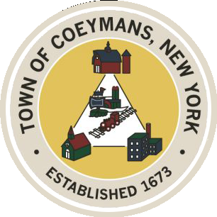
Stephen Donnelly
SUPERVISOR
COUNCIL MEMBERS
Michael J.Stott Linda S.Bruno Stephen J.Schmitt Ronald J.Hotaling
18 Russell Avenue, Ravena, New York 12143
(518) 756-6006 Fax: (518) 756-1991
TOWN OF COEYMANS, NEW YORK

TOWN BOARD OF THE TOWN OF COEYMANS
Town Board Meeting 6:00pm
Please silence cell phones while meeting is in progress

Date: September 11, 2025

- Call to Order – Pledge of Allegiance

- Members Present

- Public Announcements
  - Music Bingo 9/12/25 7-9pm at Rail to River Brewing
  - Evening on the Green- East Berne Band 9/17/25 6pm at Riverfront Park
  - Financial Elder Abuse Class 9/22/25 3:30pm at Ravena Senior Projects

- Approval of Minutes
4.1. Town Board Meeting 8/28/25
4.2. Special Meeting Minutes 9/3/25

- Old Business

- New Business

- Resolutions
7.1. Acceptance of Resignation of Police Officer (J. McCanney)
7.2. Hire Part Time Police Officer (M. Patterson)
7.3. Budget Transfer (Parks)
7.4. Budget Amendment (Planning Board)

- Upcoming Meetings
8.1. September 24, 2025 – PB/ZBA Meeting @ 7:00 PM
8.2. September 25, 2025 – Town Board Meeting @ 6:00 PM
8.3. October 9, 2025 – Town Board Meeting @ 6:00 PM
8.4. October 14, 2025 – PB/ZBA Meeting @ 7:00 PM

- Public Comment

- Adjourn

