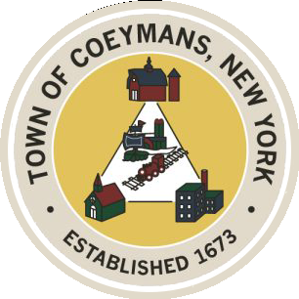
Stephen Donnelly
SUPERVISOR
COUNCIL MEMBERS
Michael J.Stott Linda S.Bruno Stephen J.Schmitt Ronald J.Hotaling
18 Russell Avenue, Ravena, New York 12143
(518) 756-6006 Fax: (518) 756-1991
TOWN OF COEYMANS, NEW YORK

TOWN BOARD OF THE TOWN OF COEYMANS
Town Board Meeting 6:00pm
Please silence cell phones while meeting is in progress

Date: October 23, 2025

- Call to Order – Pledge of Allegiance

- Members Present

- Open Public Hearing

- Public Announcements
  - 10/24/25 Romp & Read @ RCS Community Library 10-10:30AM
  - 10/24/25 Scary Movie Trivia @ Rail 2 River Brewing 7-9PM

- Approval of Minutes
4.1. Town Board Meeting 10/09/25

- Supervisor Report
  - Supervisor Report for September 2025

- Department Reports

  - Town Clerk Report for September 2025
  - Police Department Report for September 2025
  - Building Department Report for September 2025
  - Sewer Department Report for September 2025
  - Highway Department Report for September 2025
  - Liaison Reports

- Old Business
  - Public Forum for truck traffic

- New Business

- Resolutions
7.1. Abstract
7.2. Budget Transfer (HWY)

- Upcoming Meetings
8.1. November 10, 2025 – PB/ZBA Meeting @ 7:00 PM
8.2. November 13, 2025 – Town Board Meeting @ 6:00 PM
8.3. November 24, 2025 – Town Board Meeting @ 6:00 PM
8.4. November 25, 2025 – PB/ZBA Meeting @ 7:00 PM

- Public Comment

- Adjourn

