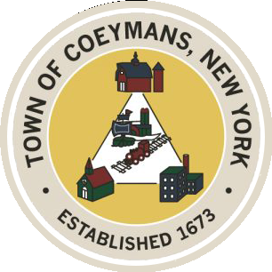
Stephen Donnelly
SUPERVISOR
COUNCIL MEMBERS
Michael J.Stott Linda S.Bruno Stephen J.Schmitt Ronald J.Hotaling
18 Russell Avenue, Ravena, New York 12143
(518) 756-6006 Fax: (518) 756-1991
TOWN OF COEYMANS, NEW YORK

TOWN BOARD OF THE TOWN OF COEYMANS
Town Board Meeting 6:00pm
Please silence cell phones while meeting is in progress

Date: October 9, 2025

- Call to Order – Pledge of Allegiance

- Members Present

- Public Announcements
  - 10/10/25 RCS K-12 Early Dismissal
  - 10/13/25 Indigenous Peoples Day: Town Offices closed

- Approval of Minutes
4.1. Town Board Meeting 9/25/25

- Old Business
  - Verkada Proposal(s)
  - New Town Office Update
  - Ultra-Violet Disinfection System
  - Truck Traffic Update

- New Business
  - “Agri-Tourism” Discussion

- Resolutions
7.1. Acceptance of Resignation of Town Prosecutor (K. McGuire)
7.2 Appointment of Town Prosecutor (A. Galgay)
7.3 Route 9W Capital Fund
7.4 Workplace Violence Prevention Plan – Hazard Reduction Team
7.5 Laberge Addendum (DASNY Grant)
7.6 “Transportation Terminal” Zoning Clarification (Public Hearing)
7.7 Weight Restriction – Version 1 (Public Hearing)
7.8 Weight Restriction – Version 2 (Public Hearing)

- Upcoming Meetings
8.1. October 22, 2025 – PB/ZBA Meeting @ 7:00 PM
8.2. October 23, 2025 – Town Board Meeting @ 6:00 PM
8.3. November 10, 2025 – PB/ZBA Meeting @ 7:00 PM
8.4. November 13, 2025 – Town Board Meeting @ 6:00 PM

- Public Comment

- Adjourn

