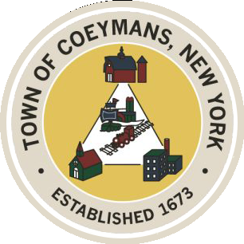
Stephen Donnelly
SUPERVISOR
COUNCIL MEMBERS
Michael J.Stott Linda S.Bruno Stephen J.Schmitt Ronald J.Hotaling
18 Russell Avenue, Ravena, New York 12143
(518) 756-6006 Fax: (518) 756-1991
TOWN OF COEYMANS, NEW YORK

TOWN BOARD OF THE TOWN OF COEYMANS
Town Board Meeting/Public Hearing 6:00pm
Please silence cell phones while meeting is in progress

Date: November 13, 2025

- Call to Order – Pledge of Allegiance

- Members Present

- Open Public Hearing (Local Law No. 1 of 2025)

- Public Announcements
  - 11/26/25 – 11/28/25 RCS School Thanksgiving recess
  - 11/27/25 & 11/28/25 Thanksgiving: Town Offices closed

- Approval of Minutes
4.1. Town Board Meeting 10/23/25

- Old Business
  - Planning Board and Zoning Board of Appeals

- New Business
  - 250 Celebration

- Resolutions
7.1 Resolution – Water Rent Re-levy
7.2 Resolution – Sewer Rent Re-levy
7.3 Resolution – Approve 2026 Budget
7.4 Resolution – Budget Transfer
7.5 Resolution – Budget Amendment
7.6 Resolution – 9W Change Order
7.7 Resolution – Site Plan Review

- Upcoming Meetings
8.1. November 24, 2025 – Town board Meeting @ 6:00 PM
8.2. November 25, 2025 – PB/ZBA Meeting @ 7:00 PM
8.3. December 8, 2025 – PB/ZBA Meeting @ 7:00 PM
8.4. December 11, 2025 – Town Board Meeting @ 6:00 PM

- Public Comment

- Executive Session – Legal Advice on FOIL Appeal

- Discussion and Action on FOIL Appeal

- Adjourn

