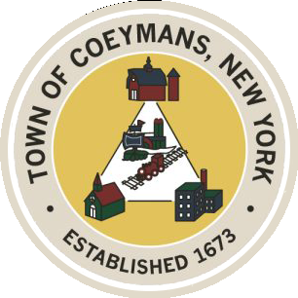
Stephen Donnelly
SUPERVISOR
COUNCIL MEMBERS
Michael J.Stott Linda S.Bruno Stephen J.Schmitt Ronald J.Hotaling
18 Russell Avenue, Ravena, New York 12143
(518) 756-6006 Fax: (518) 756-1991
TOWN OF COEYMANS, NEW YORK

TOWN BOARD OF THE TOWN OF COEYMANS
Town Board Meeting 6:00pm
Please silence cell phones while meeting is in progress

Date: November 24, 2025

- Call to Order – Pledge of Allegiance

- Members Present
- Continuation of Public Hearing opened on November 13, 2025
- Public Announcements

- Approval of Minutes
5.1. Town Board Meeting 10/23/25

- Supervisor Report
  - Supervisor Report for October 2025

- Department Reports
  - Town Clerk Report for October 2025
  - Police Department Report for October 2025
  - Building Department Report for October 2025
  - Sewer Department Report for October 2025
  - Highway Department Report for October 2025
  - Liaison Reports

- Old Business

- New Business
9.1 Schedule and authorize Notice for Public Hearing for 2026 Sewer Rates
9.2 Schedule and authorize Notice for 2026 Organizational Meeting
9.3 Discussion on Joint Meeting with PB/ZBA
9.4 Referral of Proposed Local Law No. 1 to PB/ZBA for Advisory Opinion

- Resolutions
10.1. Budget Transfer
10.2. November Abstract
10.3 Authorize 9W Moving Company

- Upcoming Meetings
8.1. December 8, 2025 – PB/ZBA Meeting @ 7:00 PM
8.2. December 11, 2025 – Town Board Meeting @ 6:00 PM
8.3. December 17, 2025 – PB/ZBA Meeting @ 7:00 PM
8.4. December 22, 2025 – Town Board Meeting @ 6:00 PM

- Public Comment

- Adjourn

