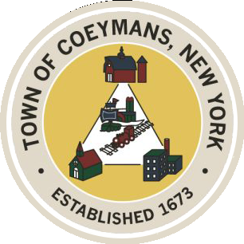
Stephen Donnelly
SUPERVISOR
COUNCIL MEMBERS
Michael J.Stott Linda S.Bruno Stephen J.Schmitt Ronald J.Hotaling
18 Russell Avenue, Ravena, New York 12143
(518) 756-6006 Fax: (518) 756-1991
TOWN OF COEYMANS, NEW YORK

TOWN BOARD OF THE TOWN OF COEYMANS
Town Board Meeting/Public Hearing 6:00pm
Please silence cell phones while meeting is in progress

Date: December 11, 2025

- Call to Order – Pledge of Allegiance

- Members Present

- Open Public Hearing (2026 Sewer Rates)

- Public Announcements
4.1 Office Move

- Approval of Minutes
5.1. Town Board Meeting 11/24/25

- Old Business
  - Transportation Terminals Definition Update
  - Site Plan Review Update

- New Business

- Resolutions
8.1 Resolution – Budget Transfer (Highway)

- Upcoming Meetings
9.1. December 17, 2025 – PB/ZBA Meeting @ 7:00 PM
9.2. December 22, 2025 – Town Board Meeting @ 6:00 PM

- Public Comment

- Adjourn

