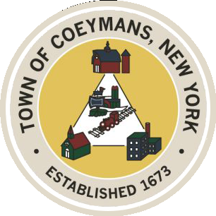
Stephen Donnelly
SUPERVISOR
COUNCIL MEMBERS
Michael J.Stott Linda S.Bruno Stephen J.Schmitt Ronald J.Hotaling
18 Russell Avenue, Ravena, New York 12143
(518) 756-6006 Fax: (518) 756-1991
TOWN OF COEYMANS, NEW YORK

TOWN BOARD OF THE TOWN OF COEYMANS
Town Board Meeting 6:00pm
Please silence cell phones while meeting is in progress

Date: December 22, 2025

- Call to Order – Pledge of Allegiance

- Members Present

- Public Announcements
  - Town Offices Half Day Christmas Eve 12/24/25
  - Town Offices Closed 12/25 & 12/26 for Christmas

- Approval of Minutes
4.1. Town Board Meeting 12/11/25

- Supervisor Report
  - Supervisor Report for November 2025

- Department Reports
  - Town Clerk Report for November 2025
  - Police Department Report for November 2025
  - Building Department Report for November 2025
  - Sewer Department Report for November 2025
  - Highway Department Report for November 2025
  - Liaison Reports

- Old Business
7.1 Proposed dates for Joint Meeting with Planning Board/Zoning Board of Appeals

- New Business

- Resolutions
9.1 Resolution – 2026 Sewer Rates
9.2 Resolution – 2026 Sewer Rates – Stonehouse Hill
9.3 Resolution – Budget Amendment – Communications Tower
9.4 Resolution – Budget Amendment – (B) Fund
9.5 Resolution – Budget Amendment – Retirement
9.6 Resolution – Budget Transfer – (A) Fund
9.7 Resolution – Budget Transfer – (A) Fund and (DB) Fund
9.8 Resolution – Abstract

- Upcoming Meetings (Dates to be approved at Organizational meeting)
10.1. January 1, 2026 – Town Board Organizational Meeting @ 3:00 p.m.
10.2 January 8, 2025 – Town Board Meeting @ 6:00 PM
10.3. January 12, 2025 – PB/ZBA Meeting @ 7:00 PM
10.4. January 22, 2025 – Town Board Meeting @ 6:00 PM
10.5. January 28, 2025 – PB/ZBA Meeting @ 7:00 PM

- Public Comment

- Adjourn

