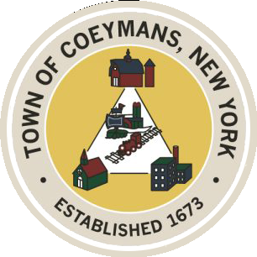
Stephen Donnelly
SUPERVISOR
COUNCIL MEMBERS
Michael J.Stott Patricia Grogan Stephen J.Schmitt
18 Russell Avenue, Ravena, New York 12143
(518) 756-6006 Fax: (518) 756-1991
TOWN OF COEYMANS, NEW YORK

JOINT MEETING OF
THE TOWN BOARD
AND
THE PLANNING BOARD / ZONING BOARD OF APPEALS
OF THE TOWN OF COEYMANS
Joint Board Meeting 6:30pm
Please silence cell phones while meeting is in progress

ALL MATTERS ARE FOR DISCUSSION PURPOSES ONLY –
NO ACTION WILL BE TAKEN

Date: January 29, 2026

- Call to Order – Pledge of Allegiance

- Members Present

- Discussion Items

  - Site Plan Review

  - Transportation Terminals Local Law
    - New R-A Zone Definition – Owner Occupied Contractor Yard
    - New R-A Zone Definition – Agricultural Event Center

  - Separation of Planning Board / Zoning Board of Appeals

- Public Comment

- Adjourn

