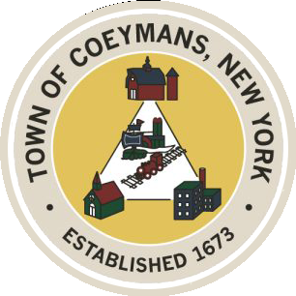
Stephen Donnelly
SUPERVISOR
COUNCIL MEMBERS
Michael J.Stott Patricia Grogan Stephen J.Schmitt
18 Russell Avenue, Ravena, New York 12143
(518) 756-6006 Fax: (518) 756-1991
TOWN OF COEYMANS, NEW YORK

TOWN BOARD OF THE TOWN OF COEYMANS
Town Board Meeting 6:00pm
Please silence cell phones while meeting is in progress

Date: January 8, 2026

- Call to Order – Pledge of Allegiance

- Members Present

- Public Announcements
3.1. Town offices closed on 1/19/25 Martin Luther King Day

- Approval of Minutes
4.1. Town Board Meeting 12/22/25

- Old Business
  - Discussion of Possible R-A Zone Definition for Agritourism / Event Space
  - Scheduling of Joint Meeting with Planning Board / Zoning Board of Appeals

- New Business

- Resolutions
  - Appointment of Town Budget Officer
  - Updated Authorization of 2026 Employee Rates
  - Appointment of Town Attorney
  - Affirm 2025 Employee Rates

- Upcoming Meetings
8.1. January 15, 2026 – PB/ZBA Meeting @ 7:00 PM
8.2. January 22, 2026 – Town Board Meeting @ 6:00 PM

- Public Comment

- Adjourn

