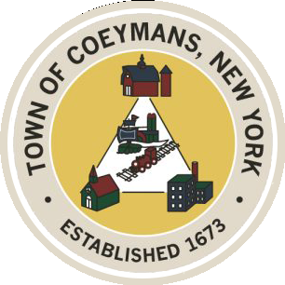
Stephen Donnelly
SUPERVISOR
COUNCIL MEMBERS
Michael J.Stott Patricia Grogan Stephen J.Schmitt
18 Russell Avenue, Ravena, New York 12143
(518) 756-6006 Fax: (518) 756-1991
TOWN OF COEYMANS, NEW YORK

TOWN BOARD OF THE TOWN OF COEYMANS
Town Board Meeting 6:00pm
Please silence cell phones while meeting is in progress

Date: January 22, 2026

- Call to Order – Pledge of Allegiance

- Members Present

- Public Announcements

- State of the Town Address

- Approval of Minutes
  - Town Board Organizational Meeting 1/1/26
  - Town Board Meeting 1/8/26

- Supervisor Report
  - Supervisor Report for December 2025

- Department Reports
  - Town Clerk Report for December 2025
  - Police Department Report for December 2025
  - Building Department Report for December 2025
  - Sewer Department Report for December 2025
  - Highway Department Report for December 2025
  - Liaison Reports

- Old Business
  - CDBG / WIIA Grant Discussion
  - Budget Officer Discussion
  - Truck Traffic
- New Business

- Resolutions
  - Budget Amendment
  - Extension of Budget Officer Stipend
  - Updated Authorization of 2026 Employee Rates
  - Abstract

- Upcoming Meetings
11.1. January 29, 2026 – Town Board / PB/ZBA Joint Meeting @ 6:30 PM
11.2. February 5, 2026 – PB/ZBA Meeting @ 7:00 PM
11.3. February 12, 2026 – Town Board Meeting @ 6:00 PM

- Public Comment

- Adjourn

