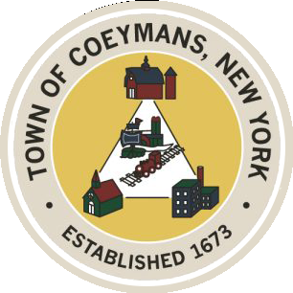
Stephen Donnelly
SUPERVISOR
COUNCIL MEMBERS
Michael J.Stott Patricia Grogan Stephen J.Schmitt
18 Russell Avenue, Ravena, New York 12143
(518) 756-6006 Fax: (518) 756-1991
TOWN OF COEYMANS, NEW YORK

TOWN BOARD OF THE TOWN OF COEYMANS
Town Board Meeting 6:00pm
Please silence cell phones while meeting is in progress

Date: February 12, 2026

- Call to Order – Pledge of Allegiance

- Members Present

- Public Announcements
3.1. Town offices closed on 2/16/26 - Presidents Day

- Approval of Minutes
  - Joint Town Board / Ravena Board of Trustees Sewer Workshop 12/18/25
  - Town Board Meeting 1/22/26

- Old Business
  - Sewer Project Phase 1 / Financing
  - Albany County Sheriff Substation MOA Discussion

- New Business

- Resolutions
  - Schedule Charter Communications Franchise Agreement Public Hearing
  - Crown Castle Tower Agreement Amendment
  - Cancel Laberge Sidewalk Study Addendum
  - Approve Laberge Mountain Road Ext. Road Study Addendum
  - Approve Purchase of Police Cars
  - Appoint PB / ZBA Member
  - Approve PB / ZBA Attorney Retainer
  - Approve Bond Counsel Retainer

- Upcoming Meetings
8.1. February 19, 2026 – PB/ZBA Meeting @ 7:00 PM
8.2. February 26, 2026 – Town Board Meeting @ 6:00 PM

- Public Comment

- Adjourn

