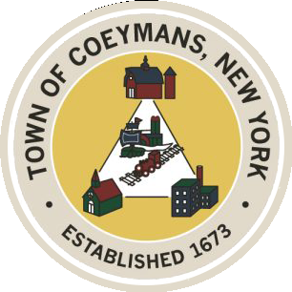
Stephen Donnelly
SUPERVISOR
COUNCIL MEMBERS
Michael J.Stott Patricia Grogan Stephen J.Schmitt
18 Russell Avenue, Ravena, New York 12143
(518) 756-6006 Fax: (518) 756-1991
TOWN OF COEYMANS, NEW YORK

TOWN BOARD OF THE TOWN OF COEYMANS
Town Board/Public Hearing 6:00pm
Please silence cell phones while meeting is in progress

Date: February 26, 2026

- Call to Order – Pledge of Allegiance
- Members Present
- Open Public Hearing (Charter Franchise Agreement)
- Public Announcements

- Approval of Minutes
  - Town Board Meeting 2/12/26

- Supervisor Report
  - Supervisor Report for January 2026

- Department Reports
  - Town Clerk Report for January 2026
  - Police Department Report for January 2026
  - Building Department Report for January 2026
  - Sewer Department Report for January 2026
  - Highway Department Report for January 2026
  - Liaison Reports

- Old Business
  - Sewer Project Phase 1/Financing

- New Business

- Resolutions
  - Charter Communications Franchise Agreement
  - Lansing Engineering Mountain Road Ext. Road Study
  - Bond Resolution WWTP Phase 1
  - Approval of Bond Counsel Retainer
  - Abstract

- Upcoming Meetings
11.1 March 5, 2026 – PB/ZBA Meeting @ 7:00 PM
11.2. March 12, 2026 – Town Board Meeting @ 6:00 PM

- Public Comment

- Adjourn

