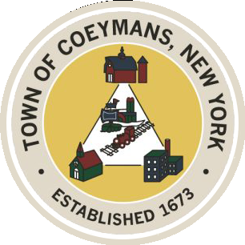
TOWN OF COEYMANS, NEW YORK
Stephen Donnelly
SUPERVISOR

18 Russell Avenue, Ravena, New York 12143
(518) 756-6006 Fax: (518) 756-1991

COUNCIL MEMBERS
Michael J.Stott Patricia Grogan Stephen J.Schmitt

TOWN BOARD OF THE TOWN OF COEYMANS
Town Board Meeting 6:00pm
Please silence cell phones while meeting is in progress

Date: March 12, 2026

- Call to Order – Pledge of Allegiance

- Members Present

- Public Announcements

- Approval of Minutes
  - Town Board Meeting 2/26/26

- Old Business
5.1 Transportation Terminals/Owner Occupied Contractor Yard Definitions
5.2 Truck Traffic Discussion

- New Business
6.1 Boys and Girls Club

- Resolutions
  - Revise Schedule for Town Board Workshops
  - Appointment of Part-Time Police Officer (N. George)
  - Appointment of Part-Time Police Officer (R. Germani)
  - Appointment of Highway Superintendent
  - Authorize Auction of Police Vehicle
  - Lansing Engineering Limekill/Mountain Road Ext. Road Study
  - Approve Laberge USDA Grant Administration Addendum
  - Approve Laberge Congressional Spending Administration Addendum

- Upcoming Meetings
8.1. March 19, 2026 – PB/ZBA Meeting @ 7:00 PM
8.2. March 26, 2026 – Town Board Meeting @ 6:00 PM

- Public Comment

- Adjourn

