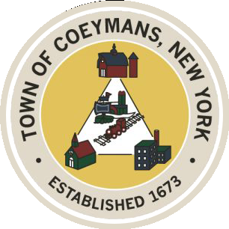
Stephen Donnelly
SUPERVISOR
COUNCIL MEMBERS
Michael J.Stott Patricia Grogan Stephen J.Schmitt
18 Russell Avenue, Ravena, New York 12143
(518) 756-6006 Fax: (518) 756-1991
TOWN OF COEYMANS, NEW YORK

TOWN BOARD OF THE TOWN OF COEYMANS
Town Board Meeting 6:00pm
Please silence cell phones while meeting is in progress

Date: March 26, 2026

- Call to Order – Pledge of Allegiance
- Members Present
- Public Announcements
  - April 7th Town Board Workshop Cancelled
  - April 9th Town Board Meeting Rescheduled (to April 14th)

- Approval of Minutes
  - Town Board Audit Meeting and Workshop 3/10/26
  - Town Board Meeting 3/12/26

- Supervisor Report
  - Supervisor Report for February 2026

- Department Reports
  - Town Clerk Report for February 2026
  - Police Department Report for February 2026
  - Building Department Report for February 2026
  - Sewer Department Report for February 2026
  - Highway Department Report for February 2026
  - Liaison Reports

- Old Business
  - Local Law No. 1 of 2026
  - Truck Traffic Discussion

- New Business
  - Summer Farmers Market

- Resolutions
  - Civill Senior Housing PILOT Agreement Assignment
  - Appointment of Highway Superintendent
  - Appointment of Board of Assessment Review Member
  - Approve Reduction of Police Chief Salary
  - Authorize Town to Accept and Issue ACH Payments
  - Approve Laberge USDA Grant Administration Addendum
  - Lansing Engineering Limekill/Mountain Road Ext. Road Study
  - Authorize Summer Farmers Market
  - Authorize Town Clerk to Attend Conference
  - Abstract

- Upcoming Meetings
11.1 April 2, 2026 – PB/ZBA Meeting @ 7:00 PM
11.2.April 14, 2026 – Town Board Meeting @ 6:00 PM

- Public Comment

- Adjourn

