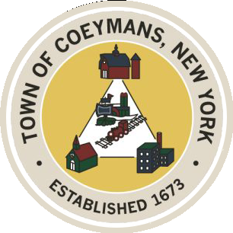
Stephen Donnelly
SUPERVISOR
COUNCIL MEMBERS
Michael J.Stott Patricia Grogan Stephen J.Schmitt
18 Russell Avenue, Ravena, New York 12143
(518) 756-6006 Fax: (518) 756-1991
TOWN OF COEYMANS, NEW YORK

TOWN BOARD OF THE TOWN OF COEYMANS
Special Town Board Meeting 6:00pm
Please silence cell phones while meeting is in progress

Date: March 26, 2026

- Call to Order – Pledge of Allegiance
- Members Present
- Resolutions
  - Appointment of Board of Assessment Review Member
  - Approve Laberge USDA Grant Administration Addendum

- Upcoming Meetings
11.1 April 2, 2026 – PB/ZBA Meeting @ 7:00 PM
11.2.April 14, 2026 – Town Board Meeting @ 6:00 PM

- Public Comment

- Adjourn

