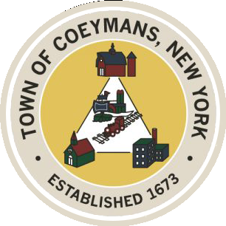
Stephen Donnelly
SUPERVISOR
COUNCIL MEMBERS
Michael J.Stott Patricia Grogan Stephen J.Schmitt
18 Russell Avenue, Ravena, New York 12143
(518) 756-6006 Fax: (518) 756-1991
TOWN OF COEYMANS, NEW YORK

TOWN BOARD OF THE TOWN OF COEYMANS
Town Board Meeting 6:00pm
Please silence cell phones while meeting is in progress

Date: April 14, 2026

- Call to Order – Pledge of Allegiance
- Members Present
- Public Announcements

- Approval of Minutes
  - Town Board Meeting 3/26/26
  - Town Board Meeting 3/31/26

- Old Business
  - Transportation Terminals/Local Contractor Yard Definitions
  - Rural Event Center Definition/Use Variance Request
  - Truck Traffic Discussion

- New Business

- Resolutions
  - Completion of Justice Audit (Eissing)
  - Completion of Justice Audit (Frese)
  - Contract Extension – Ravena Rescue Squad
  - Memorandum of Agreement - CSEA
  - Memorandum of Understanding – Westerlo Use of Dog Kennel
  - Hiring of Seasonal Laborer
  - Appointment of Part-Time “floater” Clerk
  - Approval of Joralemon Park Study
  - Lansing Engineering Limekill/Mountain Road Ext. Road Study
  - Section 3 Coordinator Designation
  - Budget Transfers – (A) Fund

- Upcoming Meetings
8.1. April 16, 2026 – PB/ZBA Meeting @ 7:00 PM
8.2. April 23, 2026 – Town Board Meeting @ 6:00 PM

- Public Comment

- Adjourn

