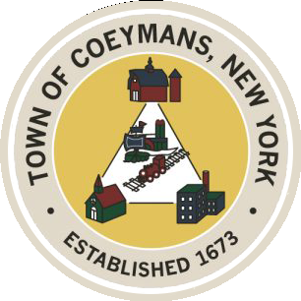
Stephen Donnelly
SUPERVISOR
COUNCIL MEMBERS
Michael J.Stott Patricia Grogan Stephen J.Schmitt
18 Russell Avenue, Ravena, New York 12143
(518) 756-6006 Fax: (518) 756-1991
TOWN OF COEYMANS, NEW YORK

TOWN BOARD OF THE TOWN OF COEYMANS
Town Board Meeting 6:00pm
Please silence cell phones while meeting is in progress

Date: April 23, 2026

- Call to Order – Pledge of Allegiance
- Members Present
- Public Announcements
  - Alcove Day 4/25/26

- Approval of Minutes

- Supervisor Report
  - Supervisor Report for March 2026

- Department Reports
  - Town Clerk Report for March 2026
  - Police Department Report for March 2026
  - Building Department Report for March 2026
  - Sewer Department Report for March 2026
  - Highway Department Report for March 2026
  - Liaison Reports

- Old Business
  - Transportation Terminals/Local Contractor Yard Definitions
  - Truck Traffic / Limekill/Mountain Road Ext. Road Study Discussion

- New Business

- Resolutions
  - Abstract

- Upcoming Meetings
10.1 May 7, 2026 – PB/ZBA Meeting @ 7:00 PM
10.2 May 14, 2026 – Town Board Meeting @ 6:00 PM

- Public Comment

- Adjourn

