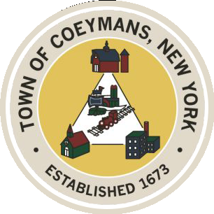
Stephen Donnelly
SUPERVISOR
COUNCIL MEMBERS
Michael J.Stott Patricia Grogan Stephen J.Schmitt
18 Russell Avenue, Ravena, New York 12143
(518) 756-6006 Fax: (518) 756-1991
TOWN OF COEYMANS, NEW YORK

TOWN BOARD OF THE TOWN OF COEYMANS
Town Board Meeting 6:00pm
Please silence cell phones while meeting is in progress

Date: May 14, 2026

- Call to Order – Pledge of Allegiance
- Members Present
- Public Announcements

- Approval of Minutes
  - Town Board Meeting 4/14/26
  - Town Board Meeting 4/23/26

- New Business
5.1 Ravena Rescue Squad Presentation – Travis Witbeck

- Old Business
  - FAST NY Grant Presentation – Nick Laraway
  - Transportation Terminals/Local Contractor Yard Definition Update
  - Rural Event Center Definition Update
  - Truck Traffic / Limekill/Mountain Road Ext. Road Study Update
  - 2026 Summer Youth Employment Update
  - 250th Celebration/Gazebo Update

- Resolutions
  - Appointment of Equipment Operator 1
  - Authorize Deputy Clerk to Attend Training
  - Budget Amendment – Sewer Fund
- Upcoming Meetings
8.1. May 21, 2026 – PB/ZBA Meeting @ 7:00 PM
8.2. May 28, 2026 – Town Board Meeting @ 6:00 PM

- Public Comment

- Adjourn

