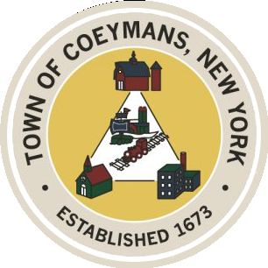
Stephen Donnelly
SUPERVISOR
COUNCIL MEMBERS
Michael J.Stott Patricia Grogan Stephen J.Schmitt
18 Russell Avenue, Ravena, New York 12143
(518) 756-6006 Fax: (518) 756-1991
TOWN OF COEYMANS, NEW YORK

TOWN BOARD OF THE TOWN OF COEYMANS
Town Board Meeting 6:00pm
Please silence cell phones while meeting is in progress

Date: May 28, 2026

- Call to Order – Pledge of Allegiance
- Members Present
- Public Announcements
  - 2026 Summer Youth Employment Applications Due June 1

- Approval of Minutes
  - Town Board Workshop 5/5/26
  - Town Board Meeting 5/14/26

- Supervisor Report
  - Supervisor Report for April 2026

- Department Reports
  - Town Clerk Report for April 2026
  - Police Department Report for April 2026
  - Building Department Report for April 2026
  - Sewer Department Report for April 2026
  - Highway Department Report for April 2026
  - Liaison Reports

- Old Business
  - Rural Event Center Definition Discussion
  - Truck Traffic / Limekill/Mountain Road Ext. Road Study Update
  - 250th Celebration Discussion
  - Ravena Rescue Squad / Ambulance District Discussion
- New Business

- Resolutions
  - Authorize Supervisor to Sign Intermunicipal Agreement (Raven’s Academy)
  - Appointment of Police Department Detective
  - Adoption of FOIL Employee Notification Policy
  - Adoption of Sexual Harassment Policy
  - Abstract

- Upcoming Meetings
10.1. June 2, 2026 – Town Board Workshop @ 6:00 PM
10.2. June 4, 2026 – PB/ZBA Meeting @ 7:00 PM
10.3. June 11, 2026 – Town Board Meeting @ 6:00 PM

- Public Comment

- Adjourn

