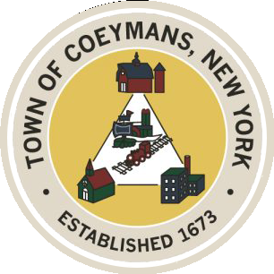
Stephen Donnelly
SUPERVISOR
COUNCIL MEMBERS
Michael J.Stott Patricia Grogan Stephen J.Schmitt
18 Russell Avenue, Ravena, New York 12143
(518) 756-6006 Fax: (518) 756-1991
TOWN OF COEYMANS, NEW YORK

TOWN BOARD OF THE TOWN OF COEYMANS
Town Board Workshop 6:00pm
Please silence cell phones while meeting is in progress

Date: May 5, 2026

- Call to Order – Pledge of Allegiance
- Members Present
- Old Business
  - Transportation Terminals/Local Contractor Yard Definitions

- New Business
  - 2026 Summer Youth Employment
  - 250th Celebration/Gazebo

- Upcoming Meetings
5.1 May 7, 2026 – PB/ZBA Meeting @ 7:00 PM
5.2 May 14, 2026 – Town Board Meeting @ 6:00 PM

- Public Comment

- Executive Session to Discuss Legal Matters

- Adjourn

