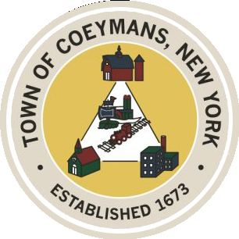
Stephen Donnelly
SUPERVISOR
COUNCIL MEMBERS
Michael J.Stott Patricia Grogan Stephen J.Schmitt
18 Russell Avenue, Ravena, New York 12143
(518) 756-6006 Fax: (518) 756-1991
TOWN OF COEYMANS, NEW YORK

TOWN BOARD OF THE TOWN OF COEYMANS
Town Board Meeting 6:00pm
Please silence cell phones while meeting is in progress

Date: June 11, 2026

- Call to Order – Pledge of Allegiance
- Members Present
- Public Announcements

- Approval of Minutes
  - Town Board Meeting 5/28/26

- Old Business
  - FAST NY Grant Presentation – Nick Laraway
  - Transportation Terminals/Local Contractor Yard Definition Discussion
  - Rural Event Center Definition Discussion
  - Truck Traffic / Limekill/Mountain Road Ext. Road Study Discussion
  - Ravena Rescue Squad / Ambulance District Discussion

- New Business

- Resolutions
  - Hire Seasonal Laborers
  - Appointment of Police Chief
  - Adoption of Sexual Harassment Policy

- Upcoming Meetings
8.1. June 18, 2026 – PB/ZBA Meeting @ 7:00 PM
8.2. June 25, 2026 – Town Board Meeting @ 6:00 PM
- Public Comment

- Adjourn

