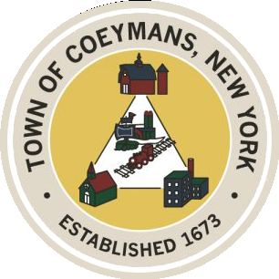
Stephen Donnelly
SUPERVISOR
COUNCIL MEMBERS
Michael J.Stott Patricia Grogan Stephen J.Schmitt
18 Russell Avenue, Ravena, New York 12143
(518) 756-6006 Fax: (518) 756-1991
TOWN OF COEYMANS, NEW YORK

TOWN BOARD OF THE TOWN OF COEYMANS
Town Board Meeting 6:00pm
Please silence cell phones while meeting is in progress

Date: June 25, 2026

- Call to Order – Pledge of Allegiance
- Members Present
- Public Announcements
  - 250 Celebration Award Presentation

- Approval of Minutes

- Supervisor Report
  - Supervisor Report for May 2026

- Department Reports
  - Town Clerk Report for May 2026
  - Police Department Report for May 2026
  - Building Department Report for May 2026
  - Sewer Department Report for May 2026
  - Highway Department Report for May 2026
  - Liaison Reports

- Old Business
  - Ravena Rescue Squad / Ambulance District Discussion
  - Transportation Terminals/Local Contractor Yard Definition Discussion
  - Rural Event Center Definition Discussion
  - Truck Traffic / Limekill/Mountain Road Ext. Road Study Update
  - Wreaths Across America Discussion

- New Business
  - Wastewater Treatment Plant Improvement Project “Phase 2” Discussion

- Resolutions
  - Appointment of Police Chief
  - Authorize Contract Extension – Ravena Rescue Squad
  - Authorization to Apply for WIIA Grant
  - Approve Laberge Addendum – General Service
  - Abstract

- Upcoming Meetings
10.1. July 2, 2026 – PB/ZBA Meeting @ 7:00 PM
10.2. July 7, 2026 – Town Board Workshop @ 6:00 PM
10.3. July 9, 2026 – Town Board Meeting @ 6:00 PM

- Public Comment

- Adjourn

