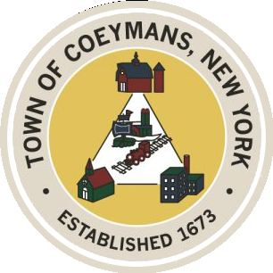
Stephen Donnelly
SUPERVISOR
COUNCIL MEMBERS
Michael J.Stott Patricia Grogan Stephen J.Schmitt
18 Russell Avenue, Ravena, New York 12143
(518) 756-6006 Fax: (518) 756-1991
TOWN OF COEYMANS, NEW YORK

TOWN BOARD OF THE TOWN OF COEYMANS
Town Board Meeting 6:00pm
Please silence cell phones while meeting is in progress

Date: August 27, 2026

- Call to Order – Pledge of Allegiance
- Members Present
- Public Announcements
  - CDBG Grant Release of Funds
  - Coeymans PBA Donations

- Approval of Minutes
  - Town Board Meeting 8/11/26

- Supervisor Report
  - Supervisor Report for July 2026

- Department Reports
  - Town Clerk Report for July 2026
  - Police Department Report for July 2026
  - Building Department Report for July 2026
  - Sewer Department Report for July 2026
  - Highway Department Report for July 2026
  - Liaison Reports

- Old Business
  - On-Going Truck Traffic Discussion
  - Zoning Code Amendments / Comprehensive Review Discussion
  - Ravena Rescue Squad / Ambulance District Discussion
  - Boys and Girls Club Update
  - Code Red Expiration / Possible Renewal

- New Business
  - Plow Truck Purchase Discussion
  - Assessor Training and Laptop Discussion
  - Flock Camera Inquiry

- Resolutions
  - Approval of Bond Resolution – Plow Truck Purchase
  - Approval of Abstract

- Upcoming Meetings
10.1. September 3, 2026 – PB/ZBA Meeting @ 7:00 PM
10.2. September 10, 2026 – Town Board Meeting @ 6:00 PM

- Public Comment

- Adjourn

