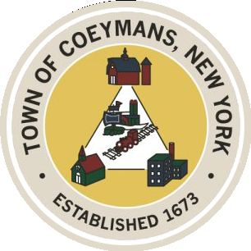
Stephen Donnelly
SUPERVISOR
COUNCIL MEMBERS
Michael J.Stott Stephen J.Schmitt Patricia Grogan
18 Russell Avenue, Ravena, New York 12143
(518) 756-6006 Fax: (518) 756-1991
TOWN OF COEYMANS, NEW YORK

NOTICE

Pursuant to Resolution No. 164-22 of 2022 (enclosed), this is to advise that Sewer Rent Charges for your property will be assessed as follows, effective July 1, 2026:
Residence: Private Homes—consisting of a single family or dual family—will be one unit per family.
Commercial: Retail space or Restaurant. Those classified as commercial will be charged 1.5 times the residential unit rate and the number of units will be calculated by the number of separate lavatories and kitchens. For example, a restaurant with 2 separate lavatories and a kitchen will be charged for 3 units at a rate that is 1.5 times that of the residential rate.
Industrial: Industrial properties lying within the Industrial Zones of the Town (I, I-2, C-IP, I-3P) will be charged 2 times that of the residential unit rate. Number of units will be determined by the number of lavatories in the building which should relate to the occupancy code.
Apartments: Apartments will be billed at the residential rate; with one apartment equaling one unit.
Vacant Parcel: Vacant parcels will be billed at the flat rate of $100 per year.

Unless otherwise amended, these rates will be utilized for all Sewer Bills issued and mailed in and after December 2026.

