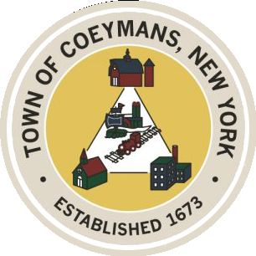
Stephen Donnelly
SUPERVISOR
COUNCIL MEMBERS
Michael J.Stott Patricia Grogan Stephen J.Schmitt
18 Russell Avenue, Ravena, New York 12143
(518) 756-6006 Fax: (518) 756-1991
TOWN OF COEYMANS, NEW YORK

TOWN BOARD OF THE TOWN OF COEYMANS
Town Board Meeting 6:00pm
Please silence cell phones while meeting is in progress

Date: September 10, 2026

- Call to Order – Pledge of Allegiance
- Members Present
- Public Announcements

- Approval of Minutes

- Old Business
  - On-Going Truck Traffic Discussion
  - Zoning Code Amendments / Comprehensive Review / RFP Discussion
  - Ravena Rescue Squad / Ambulance District Discussion
  - Flagpole Installation Update

- New Business
  - 18 Russell Storm Damage Discussion

- Resolutions
  - Appointment of Equipment Operator 1 (Glasbrener)

- Upcoming Meetings
8.1. September 17, 2026 – PB/ZBA Meeting @ 7:00 PM
8.2. September 24, 2026 – Town Board Meeting @ 6:00 PM

- Public Comment

- Adjourn

