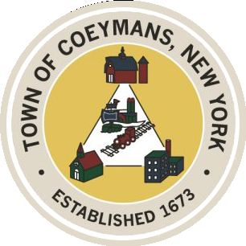
Stephen Donnelly
SUPERVISOR
COUNCIL MEMBERS
Michael J.Stott Patricia Grogan Stephen J.Schmitt
18 Russell Avenue, Ravena, New York 12143
(518) 756-6006 Fax: (518) 756-1991
TOWN OF COEYMANS, NEW YORK

TOWN BOARD OF THE TOWN OF COEYMANS
Town Board Workshop 6:00pm
Please silence cell phones while meeting is in progress

Date: September 1, 2026

- Call to Order – Pledge of Allegiance

- Workshop discussion
- Budget

Upcoming Meetings
September 3, 2026 – PB/ZBA Meeting @ 7:00 PM
September 10, 2026 – Town Board Meeting @ 6:00 PM

Public Comment
Adjourn

